Assignment 6
Roll No :- 24
------------------------------------------------------------------------------------------------------------------------------------------
A). Decision Making (if, if-else, nested if, switch) —
- Write a program to accept three numbers and print the second largest number without using logical operators (&&, ||).
- Code
<!DOCTYPE html>
<html lang="en">
<head>
<meta charset="UTF-8" />
<meta name="viewport" content="width=device-width, initial-scale=1.0" />
<title>Second Largest Number</title>
</head>
<body>
<p id="para"></p>
<p id="Ans"></p>

<script>
let a = 1;
let b = 2;
let c = 3;

let para = document.getElementById("para");
let Ans = document.getElementById("Ans");

para.innerText = "Given numbers are " + a + ", " + b + ", " + c;

if (a > b) {
if (a < c) {
Ans.innerText = "Second largest number is " + a;
console.log("Second largest number is " + a);
} else {
if (b > c) {
Ans.innerText = "Second largest number is " + b;
console.log("Second largest number is " + b);
} else {
Ans.innerText = "Second largest number is " + c;
console.log("Second largest number is " + c);
}
}
} else {
if (b < c) {
Ans.innerText = "Second largest number is " + b;
console.log("Second largest number is " + b);
} else {
if (a > c) {
Ans.innerText = "Second largest number is " + a;
console.log("Second largest number is " + a);
} else {
Ans.innerText = "Second largest number is " + c;
console.log("Second largest number is " + c);
}
}
}
</script>
</body>
</html>

- Output

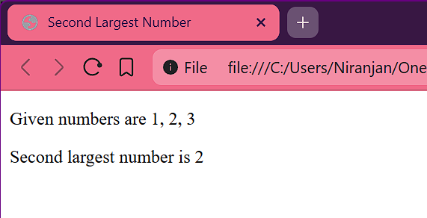

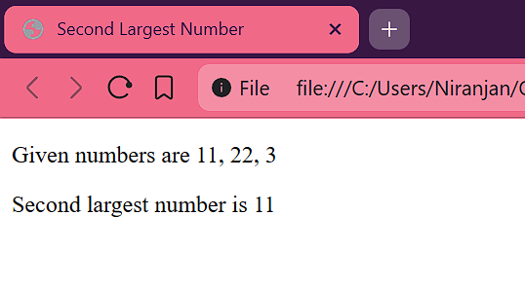

- Write a program to input marks of five subjects and display the grade according to the following rules:
  - 90-100: A+
  - 80-89: A
  - 70-79: B
  - 60-69: C
  - 50-59: D
  - <50: Fail
(Use nested if-else only)
- Code
<!DOCTYPE html>
<html lang="en">
<head>
<meta charset="UTF-8" />
<meta name="viewport" content="width=device-width, initial-scale=1.0" />
<title>Question 2 Assignment 6</title>
</head>
<body>
<p id="para"></p>
<p id="percentage"></p>
<p id="Ans"></p>

<script>
let sub1 = 50;
let sub2 = 50;
let sub3 = 50;
let sub4 = 50;
let sub5 = 50;

let per = (sub1 + sub2 + sub3 + sub4 + sub5) / 5;

let percentage = document.getElementById("percentage");
percentage.innerText = "percentage of given marks is : " + per;

let para = document.getElementById("para");
para.innerText =
"Given Subject marks are : " +
sub1 +
"," +
sub2 +
"," +
sub3 +
"," +
sub4 +
"," +
sub5;
if (per >= 90) {
Ans.innerText = "Garade is : A+";
} else if (per >= 80) {
Ans.innerText = "Garade is : A";
} else if (per >= 70) {
Ans.innerText = "Garade is : B";
} else if (per >= 60) {
Ans.innerText = "Garade is : C";
} else if (per >= 50) {
Ans.innerText = "Garade is : D";
} else {
Ans.innerText = "Garade is : Fail";
}
</script>
</body>
</html>

- Output
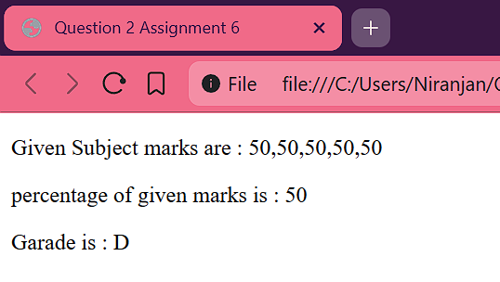

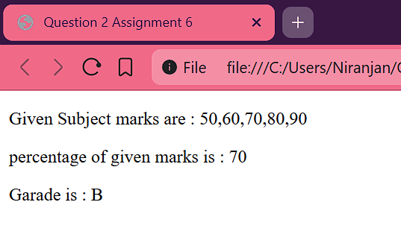

- Write a program to check whether a given year is a leap year or not without using the modulus operator (%).
- Code
<!DOCTYPE html>
<html lang="en">
<head>
<meta charset="UTF-8" />
<meta name="viewport" content="width=device-width, initial-scale=1.0" />
<title>Question 3 Assingment 6</title>
</head>
<body>
<p id="Ans"></p>
<script>
function isDivisibleBy(n, divisor) {
return Number.isInteger(n / divisor) && (n / divisor) * divisor === n;
}

let year = parseInt(prompt("Enter a number"));

let Ans = document.getElementById("Ans");

if (
isDivisibleBy(year, 400) ||
(isDivisibleBy(year, 4) && !isDivisibleBy(year, 100))
) {
Ans.innerText = year + " Given year is leap year";
} else {
Ans.innerText = year + " Given year is NOT leap year";
}
</script>
</body>
</html>

- Output

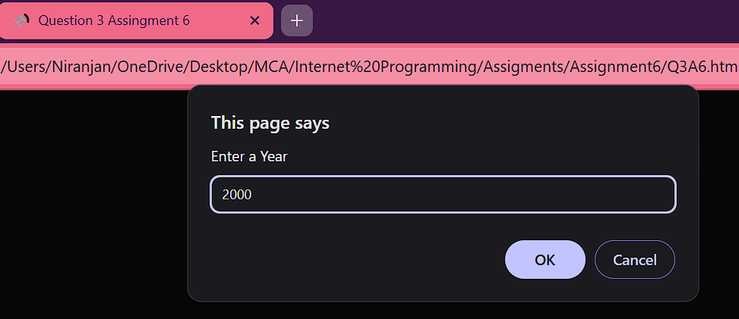

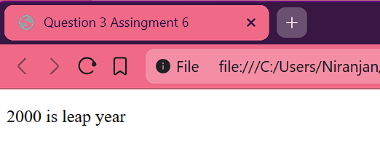

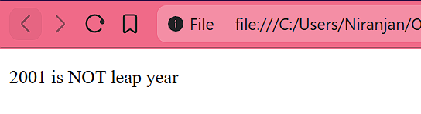

- Write a JavaScript program to accept feet and inch of two distances and print the total distance.
(Use simple variables and decision-making statement to handle inches greater than 12)
Example Logic
Distance 1: 5 feet, 8 inch
Distance 2: 3 feet, 11 inch
Total = 9 feet, 7 inch
(12 inches = 1 foot carry forward)
- Code
<!DOCTYPE html>
<html lang="en">
<head>
<meta charset="UTF-8" />
<meta name="viewport" content="width=device-width, initial-scale=1.0" />
<title>Question 4 Assignment 6</title>
</head>
<body>
<p id="Que"></p>
<p id="Ans"></p>
<script>
let feet = 12;
let inches = 12;
let feet1 = 12;
let inches1 = 12;
let totalFeet = feet + feet1;
let totalInchesh = inches + inches1;
if (totalInchesh >= 12) {
totalFeet = totalFeet + Math.floor(totalInchesh / 12);
totalInchesh = totalInchesh % 12; }
let Que = document.getElementById("Que");
let Ans = document.getElementById("Ans");
Que.innerText = `Given Foot:Inches ${feet}: ${inches} + ${feet1}: ${inches1}`;
Ans.innerText = `total = ${totalFeet}: ${totalInchesh}`;
</script>
</body>
</html>
- Output
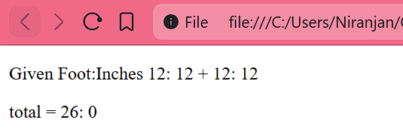

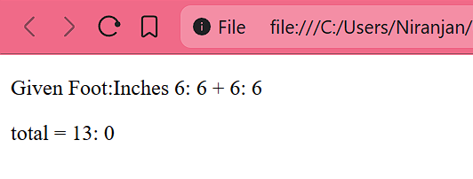

- Write a program to create a class Employee and calculate salary based on basic salary entered by user:
  - If salary > 50000, HRA = 25%, DA = 20%
  - If salary between 20000–50000, HRA = 20%, DA = 15%
  - If salary < 20000, HRA = 15%, DA = 10%
Print Gross Salary = Basic + HRA + DA.
- Code
<!DOCTYPE html>
<html lang="en">
<head>
<meta charset="UTF-8" />
<meta name="viewport" content="width=device-width, initial-scale=1.0" />
<title></title>
</head>
<body>
<script>
class Employee {
constructor(basicSalary) {
this.basicSalary = basicSalary;
this.HRA = 0;
this.DA = 0;
this.grossSalary = 0;
}
calculateSalary() {
if (this.basicSalary >= 50000) {
this.HRA = this.basicSalary * 0.25;
this.DA = this.basicSalary * 0.2;
this.grossSalary = basicSalary + this.HRA + this.DA;
} else {
if (this.basicSalary > 20000 && this.basicSalary < 50000) {
this.HRA = this.basicSalary * 0.2;
this.DA = this.basicSalary * 0.15;
this.grossSalary = this.basicSalary + this.HRA + this.DA;
} else {
if (this.basicSalary < 20000) {
this.HRA = this.basicSalary * 0.15;
this.DA = this.basicSalary * 0.1;
this.grossSalary = this.basicSalary + this.HRA + this.DA;
}
}
}
document.write(`Basic salary is : ${this.basicSalary}<br>`);
document.write(`HRA is : ${this.HRA}<br>`);
document.write(`DA is : ${this.DA}<br>`);
document.write(`Gross salary is : ${this.grossSalary}<br>`);
}
}
const basicSalary = parseInt(prompt("Enter Basic Salary"));
const emp = new Employee(basicSalary);
emp.calculateSalary();
</script>
</body>
</html>
- Output

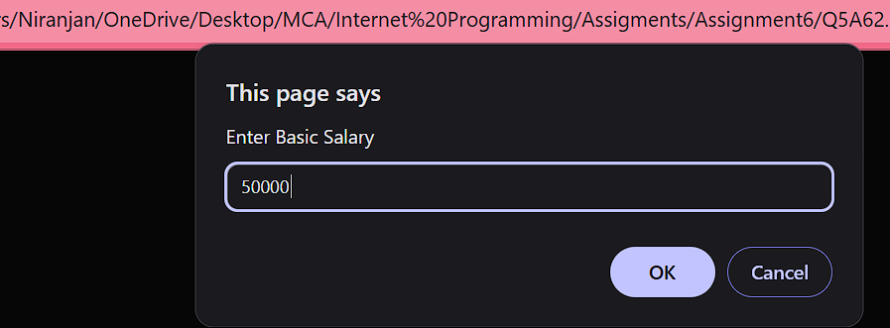

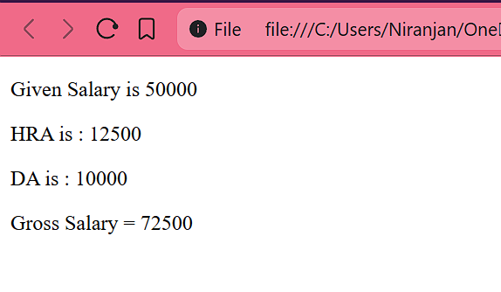

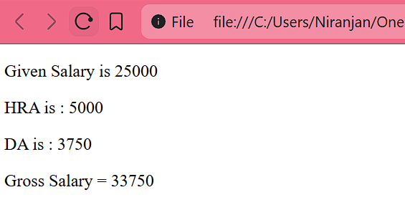

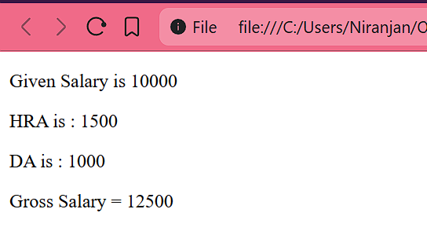

- Using switch-case, create a simple calculator that performs +, -, *, /, % operations.
- Code
<!DOCTYPE html>
<html lang="en">
<head>
<meta charset="UTF-8" />
<meta name="viewport" content="width=device-width, initial-scale=1.0" />
<title>Question 6 Assignment 6</title>
</head>
<body>
<p id="N1"></p>
<p id="N2"></p>
<p id="Ans"></p>
<script>
let num1 = parseInt(prompt("Enter first number"));
let num2 = parseInt(prompt("Enter second number"));
let op = prompt("enter operation");

let Ans = document.getElementById("Ans");
let N1 = document.getElementById("N1");
let N2 = document.getElementById("N2");

N1.innerText = `Number First : ${num1}`;
N2.innerText = `Number Second : ${num2}`;

switch (op) {
case "+":
Ans.innerText = `Addition is : ${num1 + num2}`;
break;
case "-":
Ans.innerText = `Substration is : ${num1 - num2}`;
break;
case "*":
Ans.innerText = `Multply is : ${num1 * num2}`;
break;
case "/":
Ans.innerText = `Division is : ${num1 / num2}`;
break;
case "%":
Ans.innerText = `Mod is : ${num1 % num2}`;
break;
default:
Ans.innerText = "Enter correct choice";
}
</script>
</body>
</html>

- Output

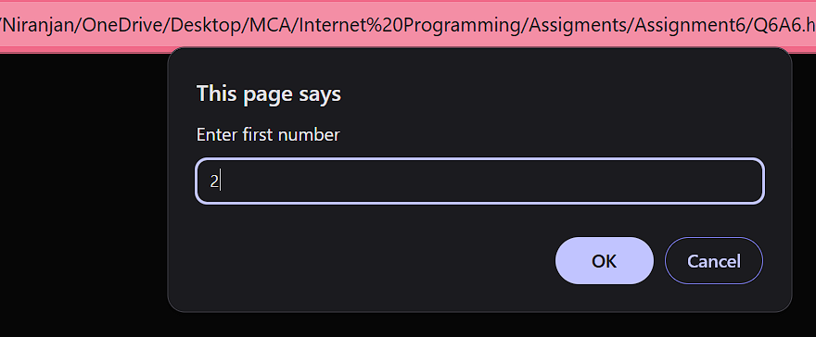

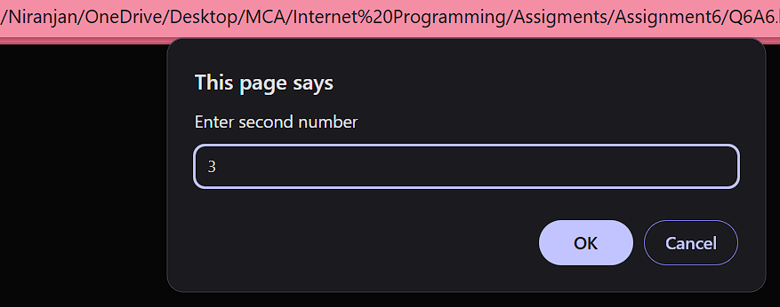

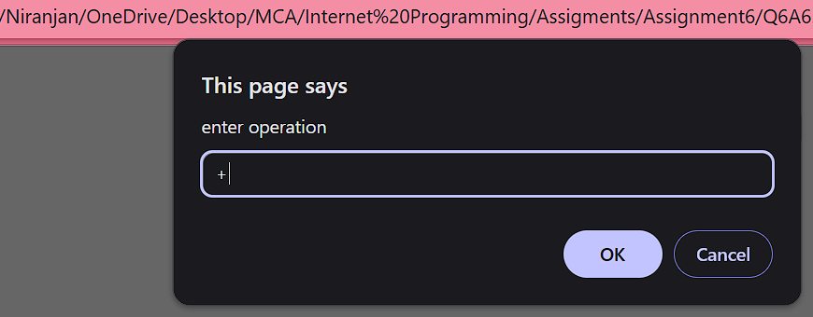

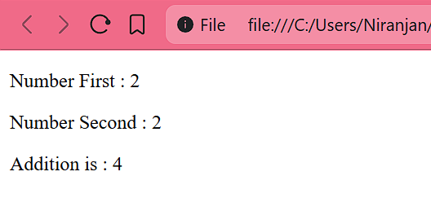

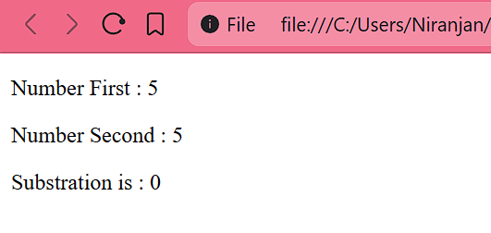

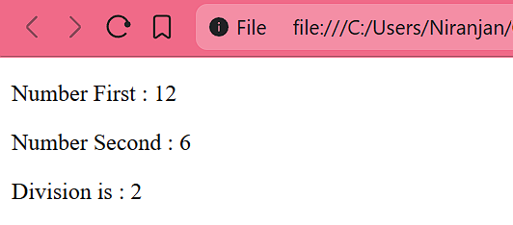

- Accept the day number (1–7) and print the day name.
- Code
<!DOCTYPE html>
<html lang="en">
<head>
<meta charset="UTF-8" />
<meta name="viewport" content="width=device-width, initial-scale=1.0" />
<title>Question 7 Assignment 6</title>
</head>
<body>
<p id="Qus"></p>
<p id="Ans"></p>
<script>
let num = parseInt(prompt("Enter Day Number from 1 - 7"));
let Ans = document.getElementById("Ans");

let Qus = document.getElementById("Qus");
Qus.innerText = `Given day number is : ${num}`;

switch (num) {
case 1:
Ans.innerText = "Sunday";
break;
case 2:
Ans.innerText = "Monday";
break;
case 3:
Ans.innerText = "Tuesday";
break;
case 4:
Ans.innerText = "Wednesday";
break;
case 5:
Ans.innerText = "Thrusday";
break;
case 6:
Ans.innerText = "Friday";
break;
case 7:
Ans.innerText = "Saturday";
break;
default:
Ans.innerText = "Enter correct choice";
}
</script>
</body>
</html>

- Output

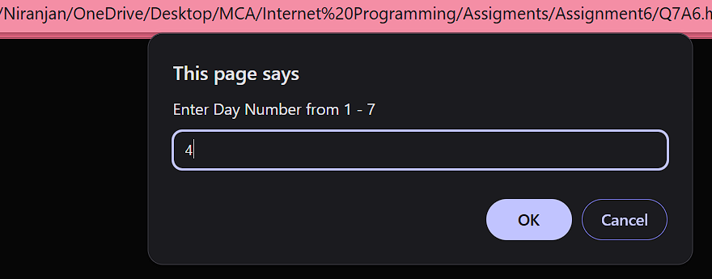

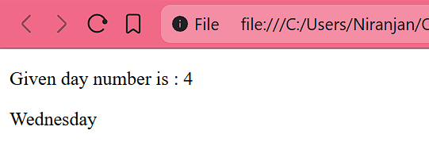

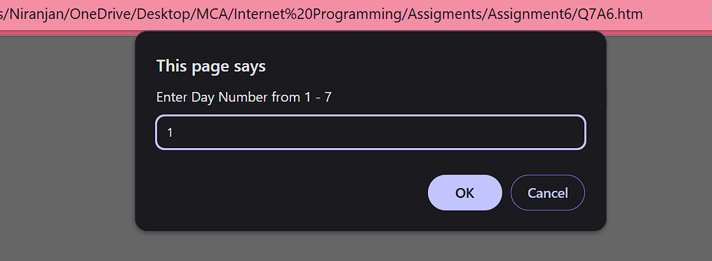

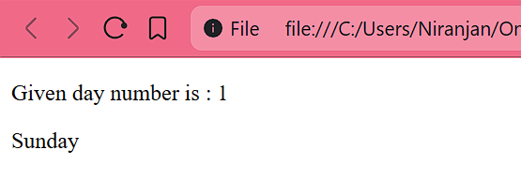

- Write a program to check if an input character is a vowel, consonant, digit, or special character. (Use nested if)
- Code
<!DOCTYPE html>
<html lang="en">
<head>
<meta charset="UTF-8" />
<meta name="viewport" content="width=device-width, initial-scale=1.0" />
<title>Question 8 Assignment 6</title>
</head>
<body>
<p id="DATA"></p>
<p id="Ans"></p>
<script>
let data = prompt("Enter data");
let Ans = document.getElementById("Ans");
let DATA = document.getElementById("DATA");
DATA.innerText = `Given data is : ${data}`;
if ((data >= "A" && data <= "Z") || (data >= "a" && data <= "z")) {
if (
data == "A" ||
data == "E" ||
data == "I" ||
data == "O" ||
data == "U" ||
data == "a" ||
data == "e" ||
data == "i" ||
data == "o" ||
data == "u"
) {
Ans.innerText = `Given data is VOWEL : ${data}`;
} else {
Ans.innerText = `Given data is CONSONANT : ${data}`;
}
} else {
if (data > "0" && data < "9") {
Ans.innerText = `Given data is NUMBER : ${data}`;
} else {
Ans.innerText = `Given data is SPECIAL CHAR : ${data}`;
}
}
</script>
</body>
</html>

- Output

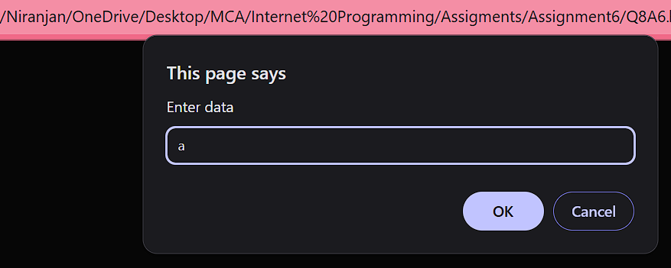

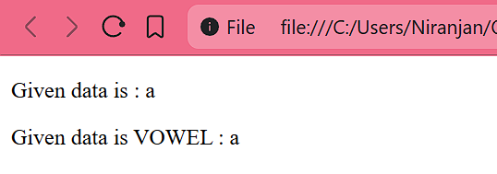

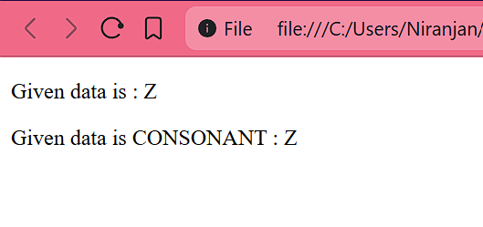

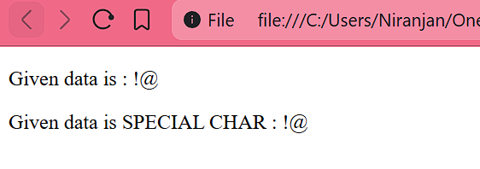

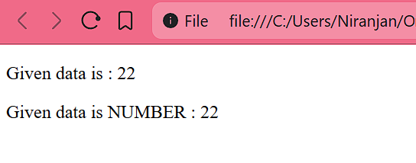

B) Looping Statements (for, while, do-while) —
- Print the Fibonacci series up to N terms.
- Code
<!DOCTYPE html>
<html lang="en">
<head>
<meta charset="UTF-8" />
<meta name="viewport" content="width=device-width, initial-scale=1.0" />
<title>Question 1 Assignment 6</title>
</head>
<body>
<p id="para"></p>
<script>
let para = document.getElementById("para");

let num = parseInt(prompt("Enter a number"));
para.innerText = `Given number is ${num}`;
let a = 0;
let b = 1;
document.write(a + "_");
document.write(b);
for (let i = 0; i < num-1; i++) {
let c = a + b;
document.write("_" + c);
a = b;
b = c;
c = a;
}
</script>
</body>
</html>
- Output
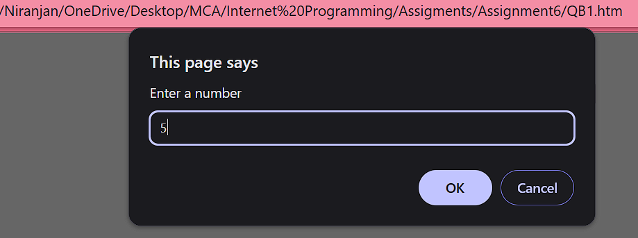

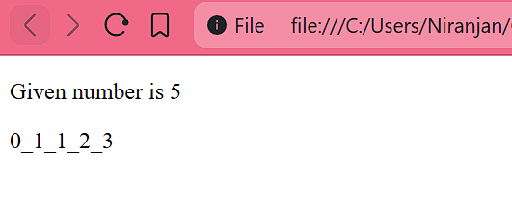

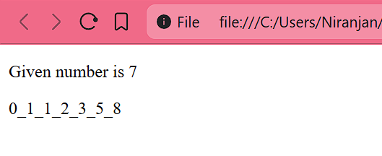

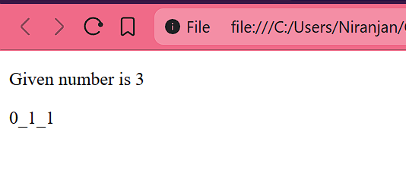

- Print all prime numbers between 1 and 100.
- Code
<!DOCTYPE html>
<html lang="en">
<head>
<meta charset="UTF-8" />
<meta name="viewport" content="width=device-width, initial-scale=1.0" />
<title>Question 2 Assignment 6</title>
</head>
<body>
<script>
for (let i = 2; i <= 100; i++) {
let isPrime = true;
for (let j = 2; j < i; j++) {
if (i % j === 0) {
isPrime = false;
}
}
if (isPrime) {
document.write(i + "_");
}
}
</script>
</body>
</html>
- Output

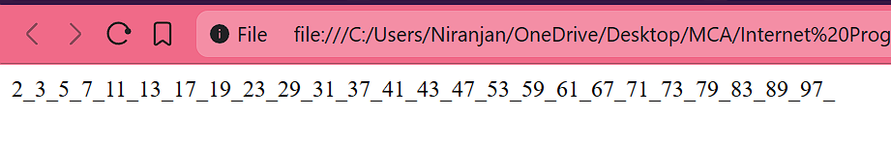
- Accept a number and print its reverse.
- Code
<!DOCTYPE html>
<html lang="en">
<head>
<meta charset="UTF-8" />
<meta name="viewport" content="width=device-width, initial-scale=1.0" />
<title>Question 3 Assignment 6</title>
</head>
<body>
<p id="Que"></p>
<p id="Ans"></p>

<script>
let num = parseInt(prompt("Enter a number"));

let Que = document.getElementById("Que");
let Ans = document.getElementById("Ans");

Que.innerText = `Given number is : ${num}`;

let temp = num;
let dig = 0;
let rev = 0;
while (temp > 0) {
dig = temp % 10;
rev = rev * 10 + dig;
temp = Math.floor(temp / 10);
}

Ans.innerText = `Reverse of given number is : ${rev}`;
</script>
</body>
</html>
- Output
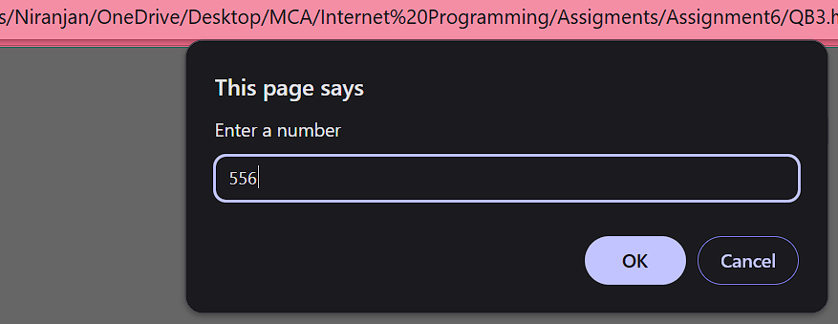

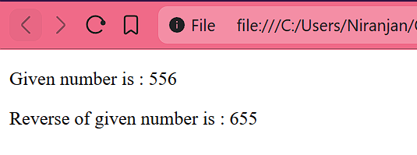

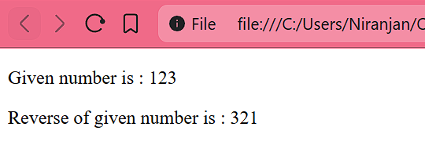

- Print multiplication table of any number up to 10.
- Code
<!DOCTYPE html>
<html lang="en">
<head>
<meta charset="UTF-8" />
<meta name="viewport" content="width=device-width, initial-scale=1.0" />
<title>Question 4 Assignment 6</title>
</head>
<body>
<script>
let num = parseInt(prompt("Enter a number"));
let j = 1;
for (let i = num; i <= num * 10; i = i + num) {
document.write(`${num} x ${j} = ${i}`);
document.write("<br>");
j++;
}
</script>
</body>
</html>
- Output
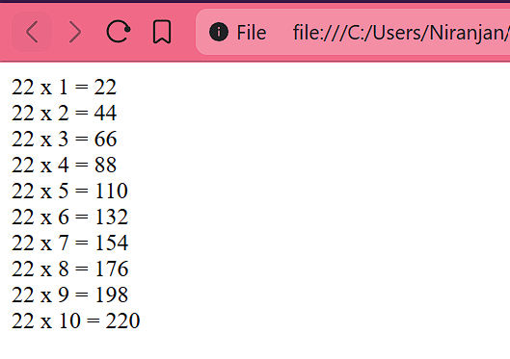
- Accept a number and check whether it is a palindrome or not.
- Code
<!DOCTYPE html>
<html lang="en">
<head>
<meta charset="UTF-8" />
<meta name="viewport" content="width=device-width, initial-scale=1.0" />
<title></title>
</head>
<body>
<script>
let num = parseInt(prompt("Enter a number"));
document.write(`Given Number is ${num}`);
document.write("<br>");
let temp = num;
let dig = 0;
let rev = 0;
while (temp > 0) {
dig = temp % 10;
rev = rev * 10 + dig;
temp = Math.floor(temp / 10);
}

if (num == rev) {
document.write(`Given Number is Palendrone`);
} else {
document.write(`Given Number is NOT Palendrone`);
}
</script>
</body>
</html>
- Output

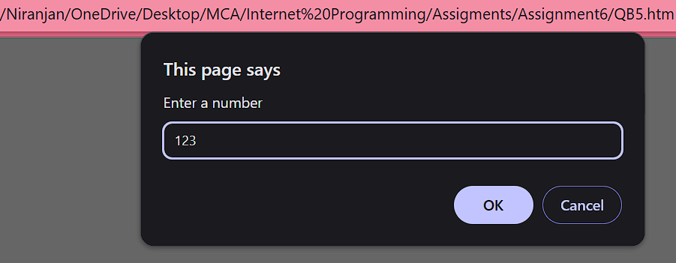

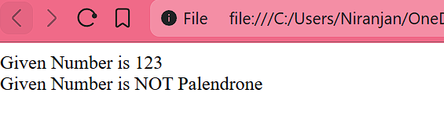

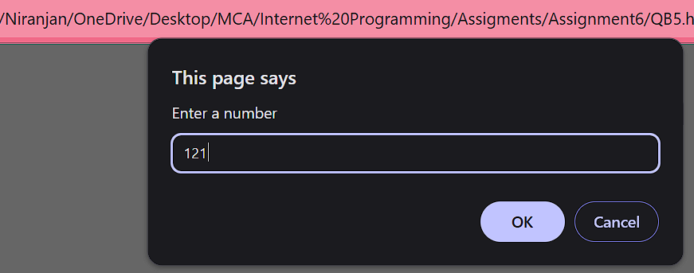

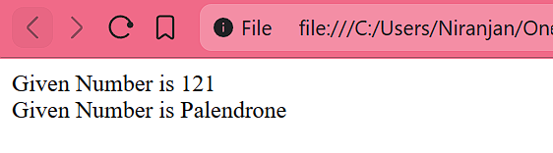

- Count the number of digits in a given number without converting it to a string.
- Code
<!DOCTYPE html>
<html lang="en">
<head>
<meta charset="UTF-8" />
<meta name="viewport" content="width=device-width, initial-scale=1.0" />
<title>Question 6 Assignment 6</title>
</head>
<body>
<script>
let st = prompt("enter a string");
document.write(`Given string is : ${st}<br>`);
let count = 0;
for (i in st) {
if (st[i] >= "0" && st[i] <= "9") {
count++;
}
}
document.write(`count of number in given string is ${count}`);
</script>
</body>
</html>
- Output

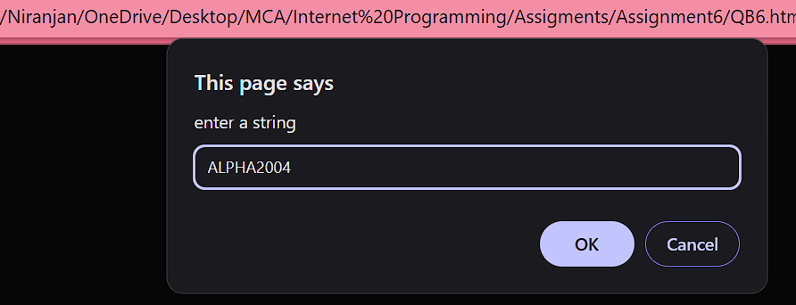

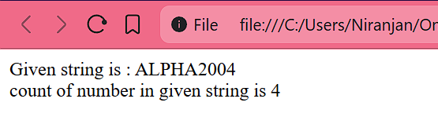

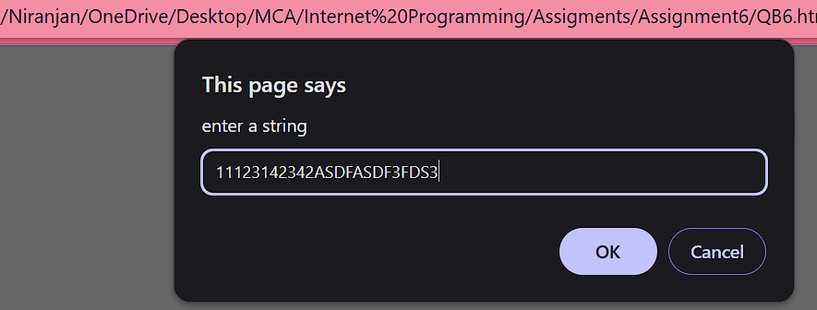

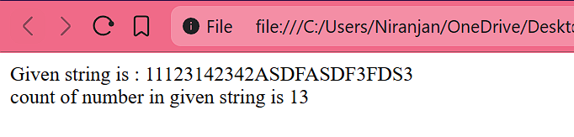

- Print the sum of all even and odd numbers separately from 1 to 100.
- Code
<!DOCTYPE html>
<html lang="en">
<head>
<meta charset="UTF-8" />
<meta name="viewport" content="width=device-width, initial-scale=1.0" />
<title>Question 7 Assignment 6</title>
</head>
<body>
<script>
let odd = 0;
let even = 0;
for (let i = 0; i <= 100; i++) {
if (i % 2 === 0) {
even = even + i;
} else {
odd = odd + i;
}
}

document.write(`Total of all even numbers : ${even}<br>`);
document.write(`Total of all odd numbers : ${odd}`);
</script>
</body>
</html>
- Output
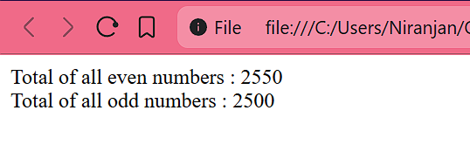
- Print the factorial of a number using a loop.
- Code
<!DOCTYPE html>
<html lang="en">
<head>
<meta charset="UTF-8" />
<meta name="viewport" content="width=device-width, initial-scale=1.0" />
<title>Question 8 Assignment 6</title>
</head>
<body>
<script>
let num = parseInt(prompt("Enter a number"));
document.write(`Given number is : ${num}<br>`);

let fact = 1;
for (let i = num; i > 0; i--) {
fact = fact * i;
}
document.write(`Factorial of given number is : ${fact}`);
</script>
</body>
</html>

- Output
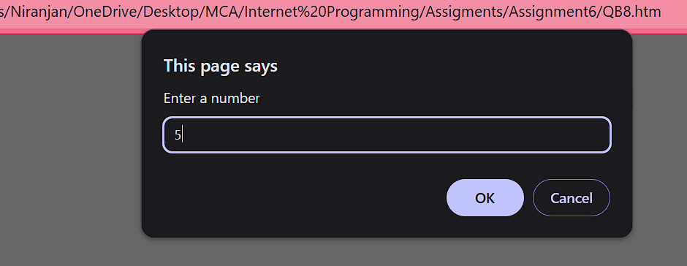

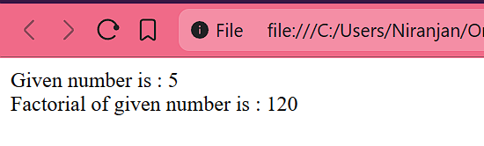

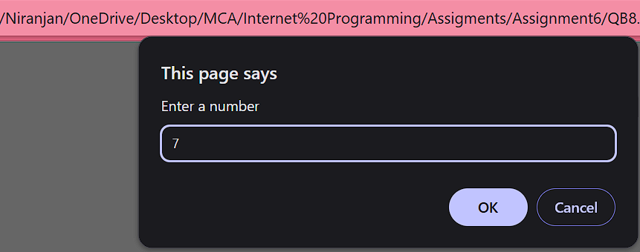

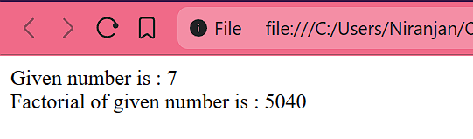

- Print a pattern as follows
1
23
456
7891
23456
- Code
<!DOCTYPE html>
<html lang="en">
<head>
<meta charset="UTF-8" />
<meta name="viewport" content="width=device-width, initial-scale=1.0" />
<title>Question 9 Assignment 6</title>
</head>
<body>
<script>
document.write("PRINTING PATTERN");
let row = parseInt(prompt("Enter row size"));
let num = 1;
for (let i = 0; i <= row; i++) {
for (let j = 1; j <= i; j++) {
document.write(`${num} `);
if (num >= 9) {
num = 0;
}
num++;
}
document.write(`<br>`);
}
</script>
</body>
</html>
- Output

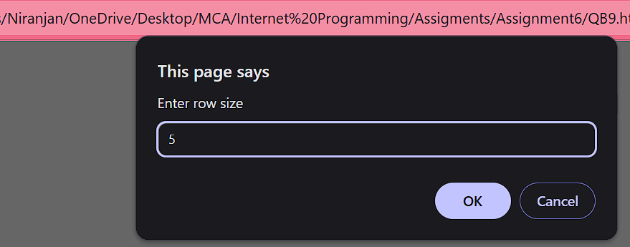

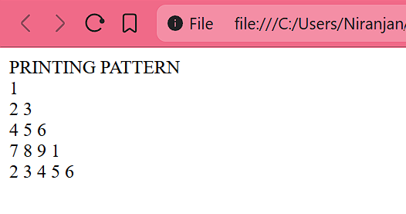

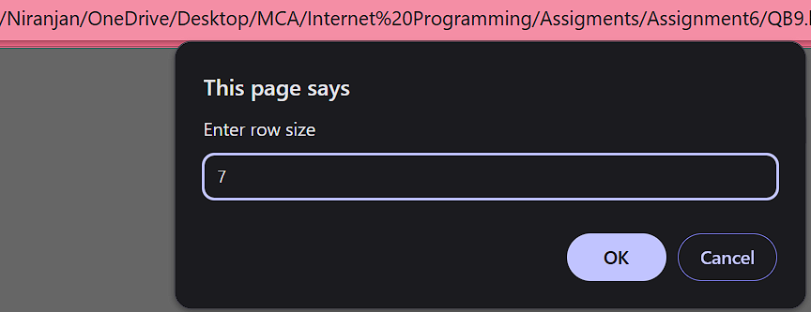

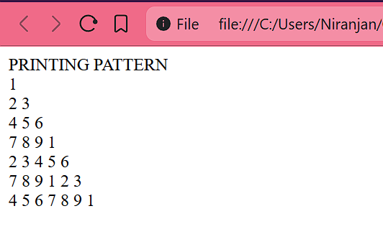

- Find the sum of digits of a number using a loop.
- Code
<!DOCTYPE html>
<html lang="en">
<head>
<meta charset="UTF-8" />
<meta name="viewport" content="width=device-width, initial-scale=1.0" />
<title>Question 10 Assignment 6</title>
</head>
<body>
<script>
let num = parseInt(prompt("Enter a number"));

document.write(`Given number is : ${num}<br>`);

let temp = num;
let dig = 0;
let sum = 0;

while (temp > 0) {
dig = temp % 10;
sum = sum + dig;
temp = Math.floor(temp / 10);
}

document.write(`Sum of given number is : ${sum}`);
</script>
</body>
</html>

- Output

